**Tung Chung Line Extension PROJECT EXECUTION PLAN**



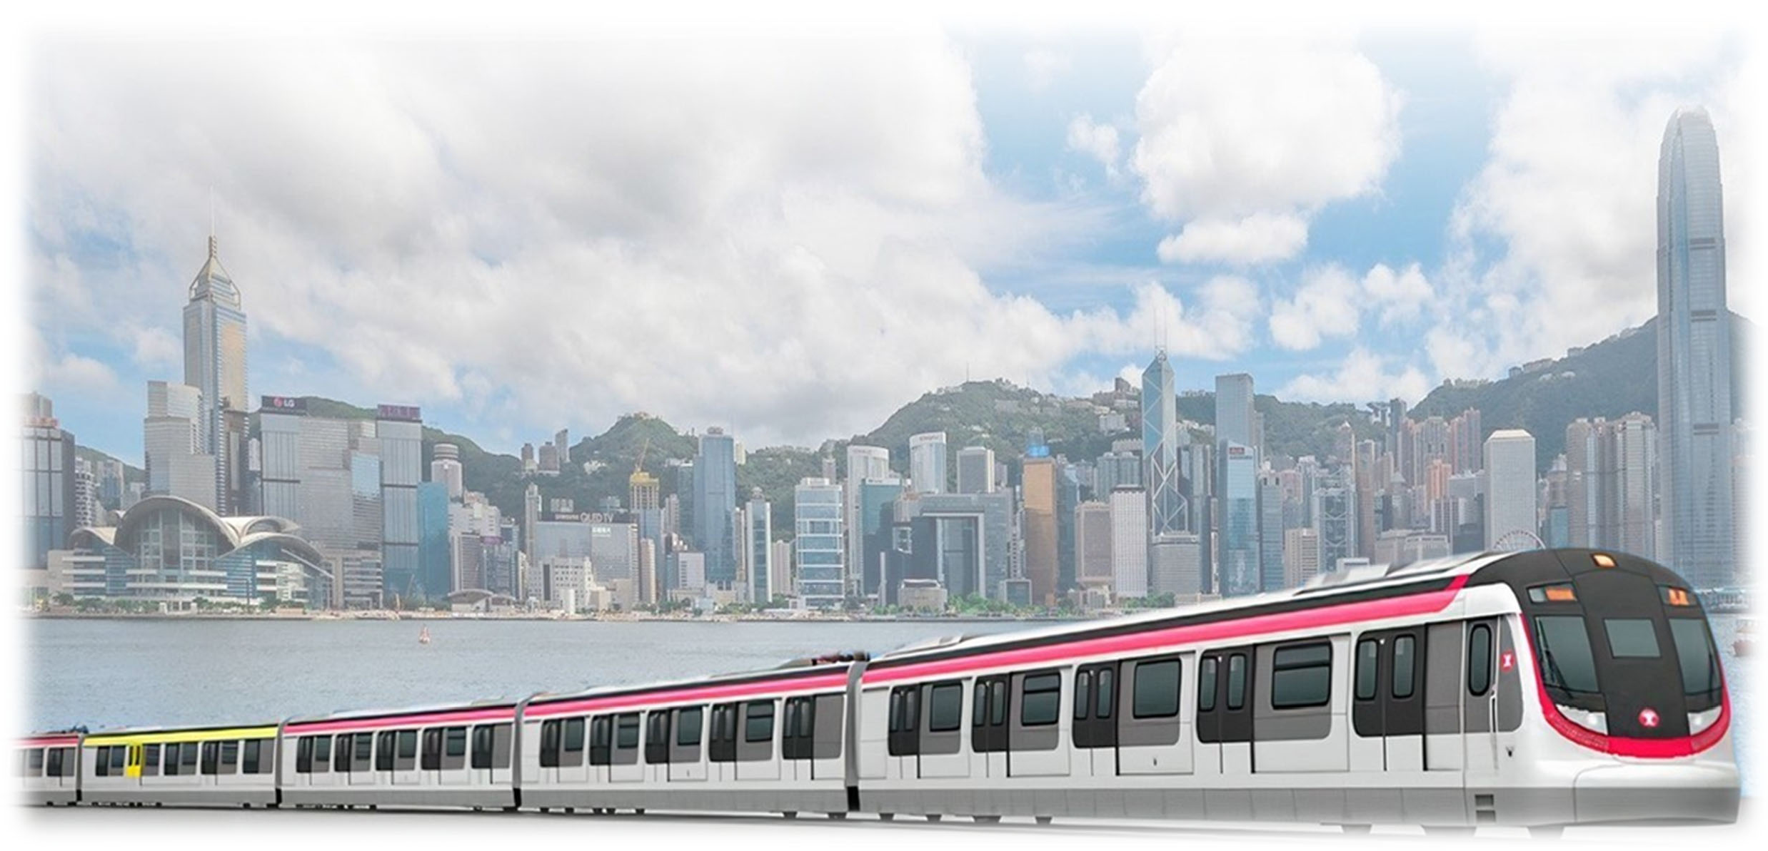Tung Chung Line Extension PROJECT EXECUTION PLAN

**Document Change Record**

|  |  |  |  |
| --- | --- | --- | --- |
| Revision | Issue Date | Page No(s). | Major Changes |
| 0 | 14 July 2023 |  |  |
|  |  |  |  |
|  |  |  |  |
|  |  |  |  |
|  |  |  |  |
|  |  |  |  |

**Document Approval Record**

|  |  |  |  |
| --- | --- | --- | --- |
|  | Job Title | Name | Signature |
| ORIGINATOR | Project Manager-TUE | Lesly Leung |  |
| CONTROLLER | General Manager – Projects Management Office | Lyndon Adolphus |  |
| REVIEWER | Chief Project Quality Manager | Tony Smith |  |
| APPROVER | General Manager – Lantau (Projects) | Neil Smith |  |

© 2022 MTR Corporation Limited.

All rights including, without limitation, intellectual property rights in and to this document and any information contained in this document are proprietary and are solely and absolutely owned by MTR Corporation Limited. The document and any information contained in the document are strictly confidential and must not be used, disclosed, transmitted, copied, printed or otherwise disseminated without the prior written consent of MTR Corporation Limited. Violators will be subject to legal sanctions such as an injunction order and will be held liable for any damages, losses, costs and expenses incurred by MTR Corporation Limited.

**CONTENTS**

1. Introduction 5
   1. Scope 5
   2. Objectives 5
   3. Ownership and Application 6
   4. Interfaces 6
2. Project Overview 8
   1. Project Objectives 8
   2. Project Scope 8
   3. Key Project Milestones 8
   4. Project Stage Overview 9
   5. Project Agreement 10
   6. Project Procurement Strategies 10
   7. Project Organization 11
   8. Project Definition Documents (PDDs) 11
3. Project Delivery Approach 12
   1. Implementation of PIMS 12
   2. Project Management, Coordination and Interface Management 12
   3. Project Governance 13
   4. Occupational Safety & Health 13
   5. Quality Management 14
   6. Environmental Management 14
   7. Stakeholder Engagement 14
   8. Project Delivery Risk Management 15
   9. Programme Management 15
   10. Design Management 15
   11. Construction Management, Testing and Commissioning 16
   12. Handover of Completed Works 16
   13. Statutory Compliance 16
   14. Information Management 17
   15. Commercial Management 17
4. External Monitoring and Control **17**
   1. Project Agreement 17

Appendix 1: Project Execution Plan Terms and Roles 19

Appendix 2: Abbreviations 20

Appendix 3: Reference Documents 21

Appendix 4: Summary list of Major Contracts 22

Appendix 5: Organisation Chart 23

Appendix 6: Project Summary Interfaces Register 24

Appendix 7: Site Supervision Team Arrangement 25

1. Introduction

# Scope

* + 1. This Project Execution Plan (PEP) applies to Tung Chung Line Extension (TUE), and all personnel of MTR Corporation Limited (MTRCL) involved in managing the project.
    2. This PEP has been developed for construction stage commencing Q2 2023 and shall be further reviewed as and when necessary.
    3. This PEP does not include Airport Railway Extended Overrun Tunnel (ARO) Works and the North Island Line (NIL) Connection Enabling Feasibility Study.

# Objectives

* + 1. This PEP is the principal management tool for the General Manager (GM) / Project Manager (PM) to manage the project. It has been developed in accordance with Project Management Procedure for developing Project Execution Plan and will be reviewed and updated half yearly. This frequency can be extended to yearly at the discretion of the GM, but as a minimum the PEP should be updated and re-issued at the commencement of each project lifecycle stage.
    2. The purpose of this PEP is to:
       - Provide a summary of the project scope, objectives, key milestones and organisation as a reference point for all personnel;
       - Document key project activities, assumptions, risks and interfaces relevant to the specific project stage;
       - Set out the how the General Manager (GM) /Project Manager (PM) will address the key management themes addressed in Project Management Procedure: leadership, partnering, team, interface coordination, management of change, communications, etc.
       - Define how PIMS and wider MTRCL requirements for management of TUE are to be implemented, and the objectives of the Project Integrated Management System Policy achieved; and
       - Summarise any specific project strategies and approaches that have been agreed, with references to related project specific management plans that have been developed where appropriate.

# Ownership and Application

* + 1. This PEP is owned and controlled by the Project Manager, and they are accountable for its ongoing maintenance to reflect the Project Management requirements relevant to each stage of the project lifecycle.
    2. Responsibility for application of this PEP is delegated by the General Manager (GM) to the Project Manager assigned to TUE.

# Interfaces

* + 1. This section outlines who needs to be engaged with in relation to Project Management requirements for TUE*.*
    2. The main internal interfaces in relation to Project Management processes for TUE include, but are not limited to the following:

|  |  |
| --- | --- |
| **WHO** | **HOW and WHY** |
| **Capital Works Technical Management Committee (CWTMC)** | Manages and reviews development of Project Definition Documents (PDDs) for use on Capital Works projects and defines the associated technical audit requirements to verify compliance of individual Projects with the appropriate PDDs. |
| **Project Management Team** | Ensures the project is delivered according to the PDD requirements and within the specific time and budget through the day-to-day First Line of Defense (“1LoD”) activities. |
| **Enabling Functions** | Includes Capital Works Business Unit (CWBU) Technical, PMO, Commercial Management, Chief of Staff and Safety Management Departments.  Provides support to Project Management Team to ensure the project is delivered according to the PDD requirements to expect quality level and within the specific time and budget through the day-to-day support, review, and audit activities.  Develops best practices and processes and provide governance on their respective expert areas.  Specific resources may be allocated to support the PMT as required by the project scope. |
| **Property and Hong Kong Transport Business Unit** | To manage and coordinate the interfaces between CWBU, PBU and HKTS scope works and operations.  Provide support to the PMT to ensure the project is delivered to expected quality level within the specific time and budget through day-to-day and regular meeting forums.  To provide direction and prioritization to the PMT at interfaces through the scheduled regular TUE Steering Committee meeting. |

* + 1. The main external interfaces in relation to Project Management processes for TUE include, but are not limited to the following:

|  |  |
| --- | --- |
| **WHO** | **HOW and WHY** |
| **Consultants, Contractors, Suppliers and Vendors** | To provide services as contracted to deliver the project in accordance with the Project Definition Documents. And their respective scope of services. |
| **Railway Development Office** | To facilitate the monitoring and control performed by Government to oversee the delivery performance of the TUE project parts related to the Project Agreement.  Provide support and oversee the project delivery to expected quality level within the specific time through regular supervision and communication platforms specified within the Project Agreement, including Project Coordination Subcommittee, Project Safety Review Committee, Project Supervision Committee and Project Board. |
| **Civil Engineering and Development Department (CEDD)** | CEDD is a Government department undertaking concurrent development projects, adjacent the TUE project site, including the C2, C6 and C7, interfacing with the TUE project. |

1. Project Overview

# Project Objectives

* + 1. The detailed Project Objectives for the TUE are contained within the Project Objectives for the Tung Chung Line Extension (TUE) document, reference TUE-PO- GM(PCENGG)-PDD-100001A1. The primary objectives of the TUE project are summarised below:
       - to provide two new railway stations at existing and new development in the vicinity of TCE and TCW;
       - to enhance the potential of the Area 113 development at TCE by railway connectivity locally and with other parts of Hong Kong;
       - to meet or exceed the financial return in the Corporation’s business case;
       - to encourage further economic and urban development and renewal in Lantau;
       - to complement the development of the long-term railway corridor.

# Project Scope

* + 1. The design, construction, completion, testing and commissioning of the Tung Chung West Station (TCW), including a crossover and an overrun tunnel at the north and south sides respectively and associated entrances and the ancillary facilities with a section of twin bored tunnels extending TCL from existing TUC by approximately 1.3 km westward to TCW.
    2. The design, construction, completion, testing and commissioning of the Tung Chung East Station (TCE) including two integrated entrances at property development area of Area 113 and two connecting footbridges with double sided retails.
    3. Retaining structures, noise barriers, site formation and other civil enabling works to the east and west of the proposed TCE for diversion of existing TCL running tracks serving the new TCE.
    4. Modifications of the existing terminus at Tung Chung Station (TUC) and the existing TCL noise barriers to the east of TUC.

# Key Project Milestones

* + 1. The key project milestones identify significant achievements throughout the duration of the works, including; works area access, commencement of significant activities, phased handover or completion of works at key interfaces, interdependencies across portfolio projects, staged and final completion. The key project milestones will be identified and monitored in the master programme.

# Project Stage Overview

* + 1. The current project stage is the Construction Stage. The following is a summary of key activities for the construction stage of the project. These key activities are identified and monitored in the Project Master Programme:
       - Completion of Signalling Equipment Room (SER) at TUC
       - Complete TBM tunnel drives
       - Completion of TCE and TCW for trackwork Degree 1
       - Degree 2 completion of TCE and TCW for systemwide E&M installation
       - FSD and all statutory inspections complete for Safe and Sound
       - Completion of the Works
    2. The following is a summary of key interfaces / dependencies for the construction stage of the project:
       - Completion of TCE and TCW for trial operation
       - Completion of Integrated Entries in Area 113 for property development
    3. The following is a summary of the project delivery risks at the Construction Stage identified for this project. The project delivery risks are reviewed and managed as described in Section 3.8.
       - Accidental damage of railway facilities impacting TCL/AEL operations
       - Accidental damage of settlement of facilities affecting operations and other parties
       - NTH availability does not meet programme demand
    4. The following is a summary of Key Stakeholders for the construction stage of the project.
       - Hong Kong Transport Services (HKTS) are the operator for the existing TCL and AEL railway adjacent TUE works sites.
       - Property Business Unit (PBU) constructing residential and commercial developments at Area 113 adjacent to TCE. Key interface locations include 2 integrated entrances for TCE.
       - Railway Development Office (RDO) will undertake monitoring and checking of the TUE construction in accordance with the Project Agreement.
       - CEDD concurrent contracts, C2, C6 & C7 interfacing with TCE and TCW constructions.

# Project Agreement

* + 1. The Project Agreement for the financing, design, construction, pre-operation, operation and maintenance of the Tung Chung Line Extension had been signed between the HKSAR and MTRCL on 28 February 2023.

# Project Procurement Strategies

* + 1. Advance works: To maximise programme certainty, advance works packages have been identified and commenced prior to the Construction Stage, a summarised below:
       - Rental of one Overhead Inspection Vehicle (OIV) for TUE
       - Supply of Tamping Machine for TUE
       - Procurement of Battery-Electric (BE) Locomotives for TUE
       - Supply of SACEM Trainborne Equipment for BE Locomotives
       - Track modification works at Tung Chung East
       - Signalling Works for Lantau Projects
       - A&A Works in Tung Chung Station for TCL Protection Works
    2. Main works contracts: The main works contracts will be procured and packaged as described below. A list of major contracts is provided in Appendix 4.
       - **Contract 1201 – Tung Chung West Station and Tunnels**; will be procured under NEC4 Engineering and Construction Contract – Option C: Target contract with activity schedule. This contract will include civil works for the TCW Station and tunnels connecting TUC and TCW; and building services (BS) and ABWF works for the TCW Station under a Design and Build arrangement. Procurement of the works utilised a two-stage tender process. This approach which will enable a flexible approach to the management of risks and opportunities, promote innovation and collaboration and incentivize cost reduction and value for money. New technologies and initiatives including Modular Integrated Construction (MIC), Design for Manufacture and Assembly (DfMA), off-site fabrication and digitalized project management will be promoted.
       - **Contract 1202 – Tung Chung East Station and Associated Enabling Works for Track Diversions**; will be procured under NEC4 Engineering and Construction Contract – Option C: Target contract with activity schedule. This contract will include civil works for TCE Station and the enabling works to facilitate diversion of the TCL tracks to the proposed alignment, building services (BS) and ABWF works under a Design & Build arrangement. Procurement of the works utilised a two-stage tender process and promoted the use of new technologies and initiatives, with similar benefits as described for Contract 1201 above.
       - **The systemwide E&M contracts** will be procured under NEC4 Engineering and Construction Contract – Option C: Target contract with activity schedule. Most of these contracts will be procured as bundled contracts with other CWBU concurrent projects, where appropriate to maximise cost effectiveness and reduce risk.

# Project Organization

* + 1. The General Manager (GM – Lantau (Projects)) will oversee the performance of the TUE project, reporting to the Capital Works Director (CWD). The General Manager E&M (GM – E&M Const) will oversee the systemwide E&M, reporting to the CWD. The TUE specific PMT will be led by the Project Manager (PM – TUE), reporting to the GM – Lantau (Projects)
    2. The PMT will comprise project specific resources, supplemented by shared Lantau portfolio staff and support function staff. The organisation chart for the TUE PMT is provided in Appendix 5.

# Project Definition Documents (PDDs)

* + 1. The Project Definition Documents at the commencement of the Construction Stage include those documents summarized below:
       - Project Objectives
       - Project Requirements
       - Project Agreement
       - Project Cost Estimate
       - Project Programme
       - Detailed Design
       - Railway / Property Interface Control Document
       - Environmental Impact Assessment and Environmental Permit
       - Buildings Department Instrument of Exemption
       - General System Assurance Requirements
       - Functional Requirements Manual
       - Design Standards Manual
       - Fire Safety Strategy Documents
       - New Works Standard Details
       - General Specifications
       - Materials & Workmanship Specifications
       - Particular Specifications

1. Project Delivery Approach

# Implementation of PIMS

* + 1. The TUE project shall implement PIMS to ensure that all work is completed in accordance with the specified criteria in a consistent and controlled manner to achieve the CWBU objectives set out in the PIMS Policy.

# Project Management, Coordination and Interface Management

* + 1. The project will be managed in accordance with the Project Management Procedure – PIMS/PJM/PRO-001/A1 and the Construction Management Procedure – PIMS/CON/PRO-001.
    2. Project resources will be recruited via the Human Resources department to suit project needs and in accordance with agreed staff forecast. Onboarding of new team members will include the MTR and project specific induction processes. Team and individual competency will be assessed annually, with training needs identified.
    3. A behavioural specialist has been engaged to promoted collaborative behaviours and an effective working environment. The specialist will conduct evaluations of team behaviours and collaborative arrangements for the PMT, support functions and stakeholders periodically.
    4. A Project Charter will be developed identifying the key behaviours for project success. The Project Charter will be developed collaboratively with internal and external parties and a Behavioural Specialist.
    5. Team building events and behavioural assessments will be undertaken periodically in conjunction with the Behavioural Specialist for MTR, Contractor, Consultant and Government staff; to promote behaviours in accordance with the Project Charter.
    6. The performance of the project will be monitored through the implementation and monitoring of Key Performance Indicators (KPI’s). These KPI’s will be updated and reported monthly.
    7. Coordination of the project will be undertaken principally through the project specific meetings, between PMT, Consultants, Contractors and Stakeholders. A project specific meeting schedule or calendar will be established and reviewed periodically.
    8. Interface management will be in accordance with the Construction Management Procedure – PIMS/CON/PRO-001. Identified requirements are documented in the Project Summary Interface Register, refer to Appendix 6.

# Project Governance

* + 1. The focus of the Project Governance Assurance during the construction stage includes oversight of project scope, progress, budget control, quality and safety. The project governance will be in accordance with the Project Governance Procedure – PIMS/GOV/PRO-001.
    2. A Project Assurance Plan will be maintained throughout the Construction Stage and reviewed periodically.
    3. To oversee the project a Project Steering Committee will be established at the commencement of the Construction Stage, with representatives from the key stakeholders including HKTS, PBU and CWBU. Coordination and other issues that cannot be resolved at project level will be elevated to the Project Steering committee for decision.
    4. The key Governance decision points for the project include:
       - The handover of the Integrated Entrance Structures to PBU for property development commencement
       - The end of the Construction Stage and approval to progress to the Testing and Commissioning Stage. This will be decided by the Commission Panel.

# Occupational Safety & Health

* + 1. The safety and welfare of all persons on or involved on the delivery of the project is paramount. The project safety will be principally managed in accordance with the Occupational Safety and Health Management Procedure – PIMS/OSH/PRO-001/A2 and Health and Safety Management Manual – D/PROJ/GEN/H&S/MAN/001/A9.
    2. To address construction safety risk and hazards, a Safety Management Plan is established and maintained for the duration of the project. The safety Management Plan is available on iShare.
    3. To address project specific risk and hazards, a project specific safety programme shall be established annually, targeted to address identified project specific safety risks. The project specific programme will include project specific safety goals, which will be aligned with the CWBU safety goals.
    4. The project safety performance will be monitored with the agreed safety KPI’s and reported monthly in the Monthly Project Progress Report and Project Agreement Report.

# Quality Management

* + 1. The quality management of the works will be undertaken in accordance with the Project Quality Assurance Procedure – PIMS/PQA/PRO-001.
    2. A project specific Project Quality Plan shall be maintained for planning, implementation and reviewing the quality performance of the project. The project specific Project quality Plan is reference TUE/PQP/001.
    3. Quality performance shall be monitored with the agreed quality KPI’s and reported monthly in the Monthly Project Progress Report and the Project Agreement Report.

# Environmental Management

* + 1. The environmental management of the works will be in accordance with the Environmental Management Procedure – PIMS/ENV/PRO-001.
    2. An Environmental Management Plan (EMP) will be developed by the Contractors for the Project explaining how the environmental management system of the project will be implemented, in order to ensure compliance with the approved TUE EIA report, TUE Environmental Permit (EP) and Contract requirements.
    3. Each Contractor will prepare their own contract specific EMP. The Contractor shall regularly review any significant changes in the approved EMP and update the EMP as necessary.
    4. Environmental Monitoring and Audit (EM&A) programme will be implemented in accordance with the approved TUE EM&A Manual under Environmental Impact Assessment Ordinance Cap. 499 (EIAO) to ensure compliance with the recommendations in the approved TUE EIA report.
    5. Environmental KPI’s will be reported in the Monthly Project Progress Report and the Project Agreement Report.

# Stakeholder Engagement

* + 1. A two-tier management structure is adopted for managing stakeholder engagement in CWBU. The Stakeholder Engagement (SE) programmes for all projects and the CWBU will be overseen by the Capital Works Stakeholder Engagement Committee (CWSEC).
    2. The Stakeholder Engagement Plan (SEP) is the principal management tool for managing the SE process of the project, ref TUE/STE/SEP-001/A1. The SEP sets out the key objective to capture and prioritize appropriate actions and activities to engage the stakeholders.
    3. Stakeholder related KPI’s will be reported in the Monthly Project Progress Report and the Project Agreement Report.

# Project Delivery Risk Management

* + 1. Project delivery risks will be managed in accordance with the Project Delivery Risk Management procedure – PIMS/RSK/PRO-001 and the NEC4 Early Warning system, for contracts procured using the NEC4 form of contract.
    2. Project risk management strategy will be defined within the latest project specific Project Delivery Risk Management Plan.
    3. Project-wide risks will be identified and recorded on the Project Delivery Risk Register – PIMS/RSK/IFT-001. This register will be maintained with current project risks during monthly project risk review meetings.
    4. In addition, contracts under NEC4 Engineering and Construction Contract will identify contract specific risks at Early Warning meetings. These risks will be managed following NEC4 guidelines for Early Warning management.
    5. Proactive reporting of identified risks and ‘early warnings’ will be reported to RDO, for risks including public and railway safety, in accordance with the Project Agreement. These risks will be reported quarterly in the Project Agreement Report.

# Programme Management

* + 1. The project programme will be managed in accordance with the Programme Management Procedure – PIMS/PGM/PRO-001.
    2. The Project Master Programme (PMP) will be developed from the Integrated Master Programme (IMP), with critical interdependencies identified and monitored.
    3. Programme related KPI’s will be reported in the Monthly Project Progress Report and Project Agreement Report.

# Design Management

* + 1. The project design will be managed in accordance with the Design Management Procedure – PIMS/DEM-PRO-001 and the Design Management and Assurance Plan – TUE/DEM/DMAP-001.
    2. The permanent works design will be undertaken by the respective contractors and approved by MTR.
    3. Temporary works, and aspects of the building services and ABWF design will be undertaken by the Contractor. These designs will be coordinated with the Consultant and approved by MTR.
    4. As far as is practicable, the design will be undertaken using building information modelling, with 2D information generated from 3D federated models. Model federation will be managed by the Contractor and defined within the approved BIM Execution Plan.
    5. Design related KPI’s will be reported in the Monthly Project Progress Report and the Project Agreement Report.

# Construction Management, Testing and Commissioning

* + 1. The project construction management will be in accordance with the Construction Management Procedure – PIMS/CON/PRO-001.
    2. The project testing and commissioning will be in accordance with the Testing and Commissioning Procedure – PIMS/TNC/PRO-001.
    3. Site supervision of construction activities of works under the IoE and Buildings Ordinance will be inspected and supervised by the Project AP, RSE and RGE, provided by the respective civil contracts. The AP, RSE and RGE will manage their respective TCP teams to conduct inspections in accordance with the Buildings Department Code of Practice for Site Supervision of Buildings.
    4. The MTR site supervision team will endure compliance with MTR quality and safety processes in accordance with PIMS and the approved Project Management Plan. The MTR site supervision team will assist in the coordination of site activities between interfacing Contractors, HKTS and Railway Protection teams.
    5. The working arrangement and allocation of responsibilities between MTR supervision team and the AP, RSE and RGE teams in shown in Appendix 7.

# Handover of Completed Works

* + 1. The handover of completed works will be in accordance with the Handover of Completed Works Procedure – PIMS/HCW/RPO-001.
    2. The first major handover of completed works will be the diverted TCL down and up tracks at TCE to HKTS.
    3. The second major area for handover of completed works will be for the Integrated Entrances at TCE to PBU.
    4. The final major area for handover will be at the Completion of the Works for TCE and TCW station to HKTS.

# Statutory Compliance

* + 1. The statutory compliance of the works will be carried out in accordance with the Statutory Compliance Procedure.
    2. The project works are divided between those subject to Buildings Ordinance (BO) and those subject to the approved Instrument of Exemption (IoE)/ the Statement of Intent (SOI). The works supporting future topside development are subject the BO, and include; the foundations, pile caps and associated structures used to support future property deck. The modification works of Tung Chung Station for line extension is subject to SOI. The works associated without future topside development, are subject to the IoE, and include; the stations and tunnels.
    3. The works will be constructed in accordance with approved design submitted either for full approval under the BO in cases where the works are not exempted from the BO; or acknowledged under consultation under the IoE in case where the works are exempted from the BO.
    4. The works will be carried out in compliance with the requirements stipulated under other submissions or inspections made with regard to and including the Station and Transport Integration Committee (STIC), Safety and Security Coordinating Committee (SSCC) and the Trackside Safety and Security Committee (TSSC), RB-EMSD, FSD and other regulatory bodies.
    5. The MTR staff employed on the project will be supplemented with AP/RSE/RGE inspectorate teams to undertake independent works inspections to ensure compliance with approved design and statutory requirements.

# Information Management

* + 1. The project information (BIM, drawings, specifications, reports etc) shall be managed using a Common Data Environment (CDE), allowing efficient issue, storage and retrieval of materials. Common Data Environment (CDE) will serve as a means for sharing information within MTR, Contractors, Consultants and as platform for sharing information to the Government.
    2. Commercial projects information shall be managed using CEMAR. This system will be used to administer the NEC4 contract.

# Commercial Management

* + 1. The commercial management will be undertaken in accordance with the Commercial Management and Procurement and Supply Chain procedure.
    2. The cost control of the construction phase will be carried out in accordance with the Cost Control Procedure for the Project Construction Phase.

1. External Monitoring and Control

# Project Agreement

The TUE project shall implement specific arrangements as set out within the Project Agreement, to support the monitoring and control undertaken by RDO.

Appendix 1: Project Execution Plan Terms and Roles

The following terms and roles are used across this Project Execution Plan:

# Project Execution Plan terms:

|  |  |
| --- | --- |
| **Term** | **Description** |
| **Project Definition Documents (PDDs)** | A hierarchy of documents which defines the performance requirements and objectives of a particular project. |
|  |  |
|  |  |
|  |  |
|  |  |
|  |  |
|  |  |

**Project Execution Plan roles:**

|  |  |
| --- | --- |
| **Role** | **Description** |
|  |  |
|  |  |
|  |  |
|  |  |
|  |  |
|  |  |
|  |  |

Appendix 2: Abbreviations

|  |  |
| --- | --- |
| **Abbreviation** | **Definition** |
|  |  |
| **CCM** | Chief Construction Manager |
| **CDM** | Chief Design Manager |
| **CPQM** | Chief Project Quality Manager |
| **CWTMC** | Capital Works Technical Management Committee |
| **GM** | General Manager |
| **IoE** | Instrument of Exemption |
| **PDD** | Project Definition Documents |
| **PM** | Project Manager |
| **PMT** | Project Management Team |
|  |  |
|  |  |
|  |  |
|  |  |
|  |  |
|  |  |
|  |  |
|  |  |
|  |  |
|  |  |
|  |  |

Appendix 3: Reference Documents

**PIMS References:**

**Policy:**

* PIMS/POL-001 Project Integrated Management System (PIMS) Policy

**Procedures:**

* PIMS/CON/PRO-001 Construction Management Procedure
* PIMS/DEM/PRO-001 Design Management Procedure
* PIMS/ENV/PRO-001 Environmental Management Procedure
* PIMS/GOV/PRO-001 Project Governance Procedure
* PIMS/HCW/PRO-001 Handover of Completed Works Procedure
* PIMS/LAN/PRO-001 Land Administration Procedure
* PIMS/OSH/PRO-001 Occupational Safety & Health Procedure
* PIMS/PGM/PRO-001 Programme Management Procedure
* PIMS/PIM/PRO-001 Project Information Management Procedure
* PIMS/PJM/PRO-001 Project Management Procedure
* PIMS/PRI/PRO-001 PIMS Management Review & Improvement Procedure
* PIMS/PQA/PRO-001 Project Quality Management Procedure
* PIMS/RSK/PRO-001 Project Delivery Risk Management Procedure
* PIMS/STC/PRO-001 Statutory Compliance Procedure
* PIMS/STE/PRO-001 Stakeholder Engagement Procedure
* PIMS/TNC/PRO-001 Testing & Commissioning Management Procedure

**Project Document References:**

* Project Management Plan
* Project Design Management Plan
* Project Quality Plan
* Project Environmental Management Plan
* Project Risk Management Plan
* Project Assurance Plan
* Project Stakeholder Engagement Plan
* Project Design Management and Assurance Plan
* Project Safety Management Plan

Appendix 4: Summary list of Major Contracts

|  |  |
| --- | --- |
| **Contract** | **Title** |
| 1201 | Tung Chung West Station and Tunnels |
| 1202 | Tung Chung East Station and Associated Enabling Works for Track Diversions |
| 1220 | Trackwork and Overhead Line System for TUE |
| 1233 | Alteration and Addition Works in Tung Chung Station for Tung Chung Line Protection Works |
| 1252 | Signaling for TUE, SHO, SHD-1 & ARO |
| 1253 | Trackside Auxiliaries and TECS for TUE & SHO |
| 1254 | PSD & APG for TUE & SHO |
| 1255 | Power Supply for TUE, SHO & SHD-1 |
| 1257 | Lift for TUE, SHO & ARO |
| 1258 | Escalators for TUE & SHO |
| 1259 | Main Control System for TUE & SHO |
| 1260 | Communication System TUE, SHO & SHD-1 |
| 1261 | Radio System for TUE, SHO & SHD-1 |
| 1262 | Automatic Fare Collection system for TUE & SHO |
| 1263 | Security Access Management System for TUE, SHO & SHD-1 |
| 1269 | Passenger Mobile System for TUE & SHO |

Appendix 5: Organisation Chart

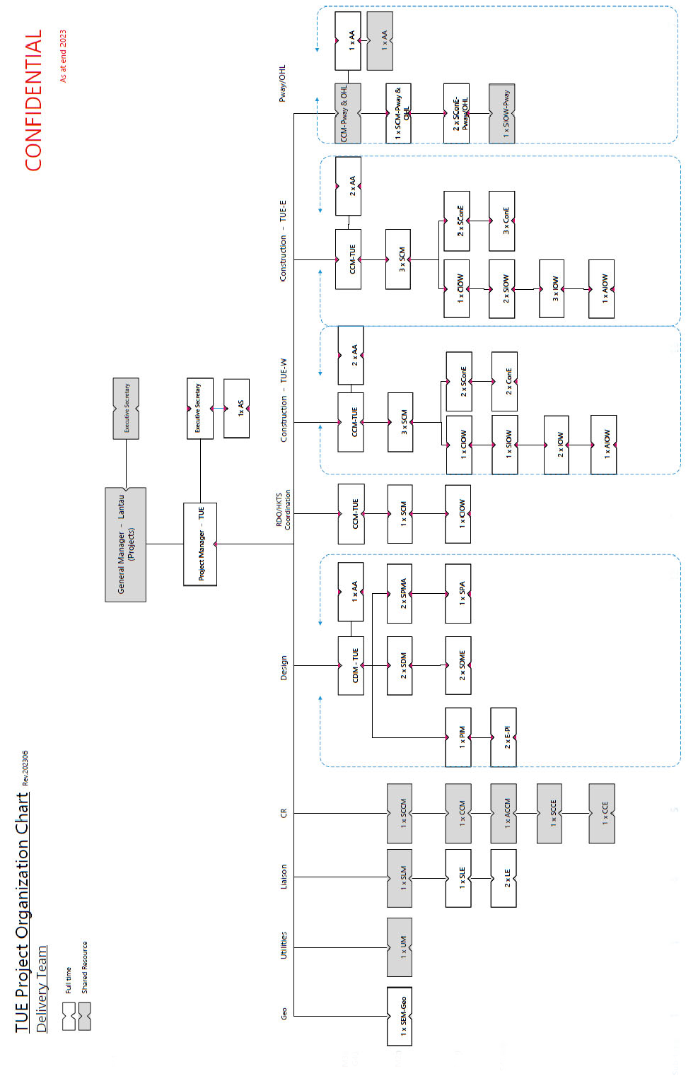

Appendix 6: Project Summary Interfaces Register

|  |  |
| --- | --- |
| **Ref.** | **Definition** |
| 1. | CEDD C1, C2, C3, C6, C7 & C9 works |
| 2. | Property Business Unit – Private Development in Area 113 |
| 3. | Hong Kong Transport Service Business Unit – Operation Interface works |
| 4. | Hong Kong Transport Service Business Unit – Works at Tung Chung Station |
|  |  |
|  |  |
|  |  |
|  |  |
|  |  |
|  |  |
|  |  |
|  |  |
|  |  |
|  |  |
|  |  |
|  |  |
|  |  |
|  |  |
|  |  |
|  |  |
|  |  |

Appendix 7: Site Supervision Team Arrangement

